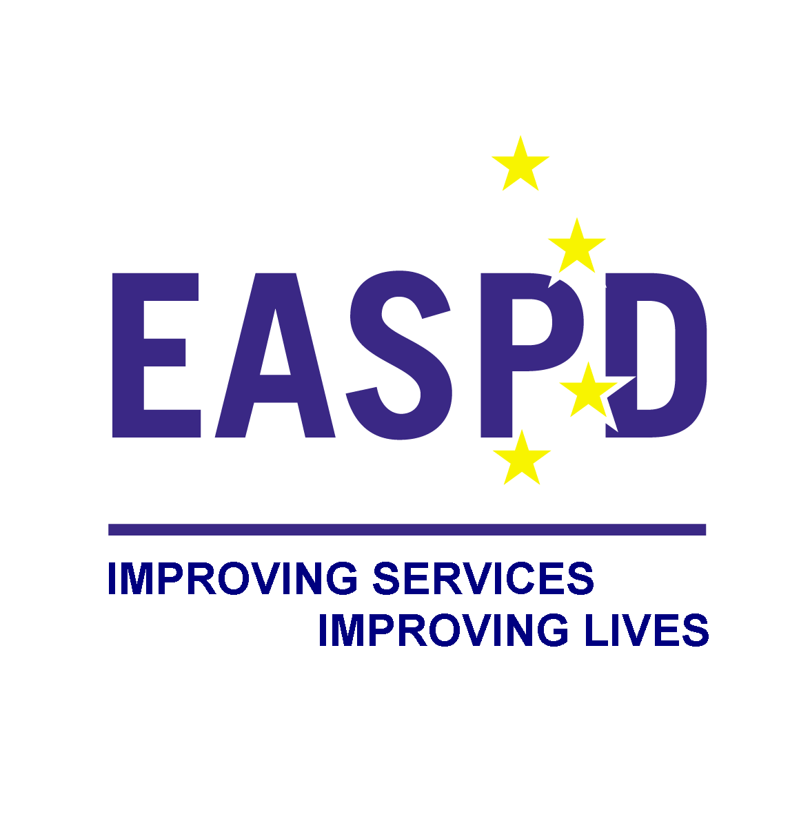

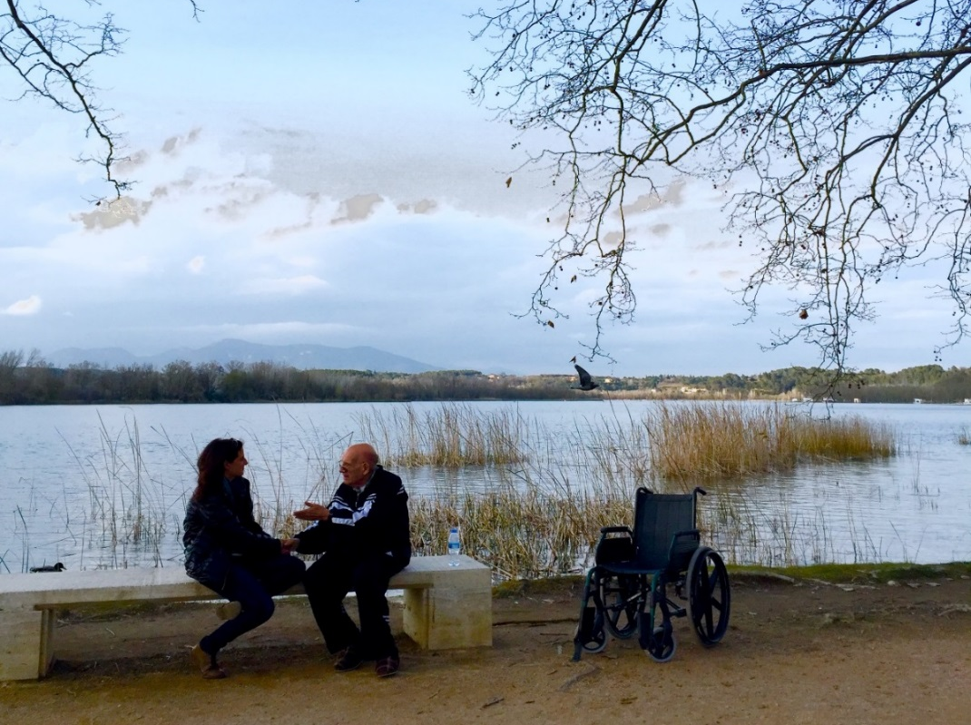
Elena Kopcová
Eva Mydlíková
Working Time Directive in Social Care and Support Services for Persons with Disabilities:
Case of Slovakia

Contents

1. Workforce in Social Care and Supported Services for People with Disabilities in Slovakia 2
2. EU Working Time Directive in Slovakia 4
2.1. Working Time in Social Care and Support Services 4
2.2. Night Work in Social Care and Support Services 7
2.3. Shift Work in Social Care and Support Services 7
2.4. Rest Time in Social Care and Support Services 7
2.5. Annual Leave in Social Care and Support Services 8
2.6. Pattern of Work in Social Care and Support Services 8
2.7. Derogations, Exceptions and Derogations by Collective Agreements 9
2.8. Safety and Health Protection in Social Care and Support Services 10
3. Implications of the EU Working Time Directive on working conditions in the Social Care and Support Services for persons with disabilities in Slovakia 11

Workforce in Social Care and Supported Services for People with Disabilities in Slovakia

On 31 December 2015, there were 5,426,252 inhabitants in the Slovak republic and the share of people with disabilities in the age of 15-65 year in population is 18,1%. There were 234,451 (4,32% of overall population in productive age) people with disabilities as invalid pension receivers.

The long-term care system remains underdeveloped. Family carers still provide a substantial proportion of long-term care in Slovakia. As a result, female inactivity due to care responsibilities ranks among the highest in the EU. The status of informal carers has been boosted since January 2017. The allowance for caring for a person with a severe disability has been increased by EUR 27.10 to EUR 247.65, benefiting 33 450 eligible recipients, and state pension insurance for carers will no longer be subject to a time limit. This should provide caregivers with better protection against poverty in old age. Likewise, the safeguard limit on the income of people with severe disabilities has been increased, by EUR 59.44 to EUR 336.75, benefiting 17 598 eligible recipients. Overall, however, progress in the transition from institutional to community-based care is too slow and does not go far enough, and support for independent living is still insufficient (Concluding Observations of the UN Committee on the Rights of Persons with Disabilities, 2016).

In 2015, there were 47,149 persons (0.87 % of overall Slovak population) as receivers of social services in 1,158 social service homes established by municipalities, self-governing regions or private providers. 491 of service providers were private (mostly non-profit organisations), taking care about 78,482 clients (mostly people with disabilities). Long term social care was provided for 38,567 clients in 997 homes (facilities for the elderly, social services homes (SSH), specialised facilities, day-care centre, supported living homes, rehabilitation centres, home-care service facilities). In 2014, there were 46,094 clients places in social service of all types, 39,078 of which were associated with year-round care (84.8 %), 1,554 with weekly care (3.4 %), 3,412 with daily care (7.4 %) and 1,925 with transient care (4.2 %). 42,418 clients` places of these are intended as being associated with social services with the character of long-term care (92 %).

In 2015, the home-care service was provided by municipalities, i.e. public providers, to 12,332 individuals by 4,867 employees of cities and municipalities and 130 private providers to 4,276 individuals (a significant year-on-year increase by 2,336 clients), working on employment contract, agreement on work activity, work performance agreement.

In 2015, cities and municipalities provided transport service to 3,032 persons with disabilities. Transport services were provided by 42 private providers (23 in 2013) for 7,188 clients, representing a year-on-year increase by 3,304 clients).

The second most important category is residential social services for people with disabilities. Overall, the number of facilities for elderly and care homes for adults is 787 facilities, with 34 931 available places and 30 396 clients. It creates 59% of facilities and 70% of available places in facilities. Those 2 categories of facilities provide services for 64% of clients from total number of social services receivers of residential care. In case of people with disabilities, services are provided in several different types of facilities, such as: social service home (SSH) for adults with physical handicap; SSH for adults with combination of handicaps; SSH for adults with sensory handicap; SSH for adults with mental disorders and failure of manners and daily health care station. Table below presents the overview of the total number of facilities, available places and inhabitants (clients) of those facilities. As it is shown, the dominant provider of services for people with disabilities are self-governmental regions. They establish more than half of the facilities (51%). This proportion is visible also from the point of view of available places as well as clients of facilities.

Table1: Number of care institutions for people with disabilities at the end of the year 2013 (next would be at the end of 2017)
 | Total | Municipality | Church legal persons | Other legal persons | Natural persons | Self-governmental region
Number of facilities | 487 | 55 | 47 | 114 | 25 | 246
Number of places | 21876 | 1303 | 987 | 3063 | 895 | 15628
Number of persons | 19133 | 993 | 795 | 2341 | 771 | 14233

Regarding the number of employees of the social services sector in Slovakia (24 865 employees of social care sector), the highest proportion, almost a half (47%) are employees of the social services homes for adult people with disabilities. Almost the quarter of employees (24%) are employees of facilities for the elderly. Third biggest employer of social care staff are employers of facilities for children (19%). Very important information related to employees is their gender structure (female-dominated sector with average age more than 40), as well as their income (average monthly wage was 858 EUR in comparison with 883 EUR as average wage of Slovak economy in 2015). Relatively low wages, hard work, often difficulties in system, organization conditions and lack of funding in the system - all of these contribute to the situation which makes social services employment not a very attractive prospect, especially for young, well-educated and trained people.

EU Working Time Directive in Slovakia

Research of WTD in Slovakia was conducted by questionnaire (17 questions) in January - February 2017. These EU directives (directly in EU level, not adopted by Slovak Republic through national labour law) know only 31% of all 30 participants, most of them are aware only national WTD in Slovak legislative and our questionnaire has also educational function, because each of WTD was well explained and defined, what our participants appreciated (e.g. they were surprised by a higher working hours at EU level as it is in our national practice).

Target group consists of 1 national policymakers, 3 municipal policymakers, 1 national trade union for social care, 1 national expert on social care sector, 1 umbrella service provider at national level, 24 service providers at local level. 38% of them are public provider and 62% are from non-profit sector. 40% of them provide only residential care and the rest mostly de-institutional community based services and home care. 44% of them provide mainly ambulant and 32% mainly terrain services, 24% of participants provide both type. Their financial sources for service provision are based mostly on dotation from Higher territorial units (municipalities), state donation system and in the third place (but not in each participant, in some of them this alternative is missing) services paid by clients as private services. Most of participants (64%) provide long-term care, education services (36%), social rehabilitation services (32%), social consulting and therapy (21%), supported employment services (18%), early childhood intervention (14%), social-protection (11%), supported living services in sheltered home care (4%) and other very different and specialised social care and supported services.

Working Time in Social Care and Support Services

The number of hours worked a year (1750) in general (not only in SCSS for PwD) is not a topic of political discussions and social partner negotiations, and Slovak labour legislation only defines weekly working time. The number of public holidays has not change significantly but, according to collective agreements, the number of companies providing holidays above the statutory level has increased. In Slovakia, average hours fell significantly over the 2000–2006 period from 42.6 to 41 hours. This is attributed to part-time workers working fewer hours rather than any reduction in the proportion of persons working very long hours, with 20% of workers apparently working more than 48 hours a week, with no discernable influence from of Directive 2000/34/EC. In Slovakia, a standard working week – 40 hours over five days – is the dominant form: 73% of workers usually work five days a week and 37% work between 39 and 41 hours. According to the Labour Code, daily working time cannot exceed nine hours and employers are obliged to distribute working time over five days when conditions allow. As regards the non-standard work arrangements in Slovakia, nearly 60% of those employed work on Saturdays and 37% on Sundays at least some of the time. This occurs in many sectors of the economy and is essentially driven by demand. Employees do not appear to be opposed to such atypical types of work, with 75% of those working on Saturdays, 70% of those working on Sundays, and 86% of those working in the evenings consider these arrangements to be satisfactory. In Slovakia, only around 1% of employees have the opportunity to determine their own work schedules. However, 4.5% of men and 6% of women effectively have the opportunity to ‘bank’ hours and take time off at a later stage. The Labour Code obliges employers to negotiate working time issues with employees or their representatives, but employees may not always feel able to insist on their rights. Flexible working time arrangements most commonly apply to those in higher ranking jobs. However, the incidence of such arrangements also varies between sectors of activity, being highest in public administration and defence (38% of employees), financial services (36%) and construction (over 30%). There appear to be no significant differences between men and women.

Most of SCSS workers for PwD in Slovakia have the usual typical working time during a week from 37,5 hours (in public sector, based on collective agreement) till 40 hours (80%), only few (20%) of them work maximum of 48 hours. About 65% of SCSS workers work usually from 8am till 4pm and 35% of them work in normal time schedules (e.g. weekend, afternoons after 4pm, nights, holidays or 3-shift cycles). Especially in a case of terrain social work, there is applied flexi-time in accordance with Labour Law Act, and working time is adapted to needs of clients, especially in case of crises intervention. In 24/7 services, there is the example of usual working time of SCSS for PwD staff in Slovakia - working time is 37,5 hours weekly; employee working regularly in 2 shift works circle has 36,25 hour weekly; employee working regularly in all 3 shifts or 24 hour services has only 35 hours working time weekly.

Almost no on-call time in SCSS for PwD in Slovakia (nobody from our participants), it is not usual, because if service providers provide services 24/7, there are shifts and staff is regularly paid as full time. Most participants agreed that fully paid on-call time has led to increased costs for running 24h services, whilst not always improving working conditions. Approximately only 15% of SCSS for PwD staff are working on stand-by time and they are no paid, classified as voluntary work or in very few cases paid as overtime. Most research participants suggest the introducing a limit to the maximum number of hours that a worker may be required to be on stand-by in a given period (for instance 24 hours a week), together with a derogation possibility to set a different limit via collective agreements). The best format would be to maximize autonomy of social partners to negotiate on this, whilst implementing limits. If social dialogue structures are not sufficiently developed, Public Authorities should support their development. Public Authorities should guarantee adequate financing to service providers to ensure quality services are provided. As it is stated in the research of application WTD in Slovak working condition, on-call time (or stand by time), especially in SCSS for PwD the same as health sector, often has the effect of overspend (overspending) the maximum weekly working time.

Slovakia have made significant changes to legislation or practice in order to comply more closely with the acquis regarding on-call time, so an 'opt-out' under WTD was introduced as part of these changes. Slovakia already allow a more limited use of the opt-out, restricted to certain jobs which make extensive use of on-call time. Under the current WTD and the possibility not to apply the limit to average weekly working time of 48 hours (the ‘opt-out’), most SCSS for PwD in Slovakia about this (almost no work - max 8% of all work in SCSS for PwD in Slovakia - over 48 hours weekly) or recommend that it should be maintained with stricter conditions for the protection of the worker, and also provided in the Directive that the opt-out cannot be combined with other derogations under the current Directive. As a reason and cases for using opt-out in SCSS for PwD in Slovakia there are only two reasons stated – a lack of staff and low wages (most qualified SCSS staff for PwD from Slovakia work in Austria as home care staff for a higher wage). With regard to emergency services, most of SCSS staff for PwD does not have any preferences for changes, and if so there should be additional derogations applicable to all or some categories of these workers, addressing their specific situation. The Social services and long-term care sectors for persons with disabilities should also receive the same additional derogations as the healthcare sector to improve continuity of service. The same problematic for the health services sector goes for the social services sector as the need for continuity often remains the same, in particular for the health and safety of the recipient of the service.

Currently, the standard limit to the reference period is 4 months (using 70% of all SCSS for PwD service providers, some of them for 1 month), which can in certain sectors be extended by law up to 6 months (11,5%), and by collective agreement it can be set up to 12 months (11,5%).

Overtime as a paid working time is in accordance with this reference period (4-12 months). The maximum for overtime is formally limited to 400 hours per a calendar year. But in reality of SCSS for PwD in Slovakia, there is often more working extra hours (e.g. emergency services during crises intervention).

Approximately 20% of service providers in Slovakia can tell that most of their workers of SCSS for PwD work also as volunteers (during unpaid care hours). It is mostly 5-10 hours weekly (over the announced 37,5 or 40 limited working time). There are mostly directors (more of NGO, but also of public providers) and the reason is that there is no money or granting for managing of service provision - most finance and grants are earmarked for services performance, not preparation of methods, studies, administration of grants, networking in local, national or transnational level, or other ways and tools of service quality improvement.

As regards the distribution of usual working time during a week in SCSS sector for PwD by job position:
- usual working time from 8am till 3,50pm of 4 pm (37,5 working hours weekly for public service provider based on collective agreement, 40 hours weekly for NGO service provider) - social workers, psychologists, special pedagogues and other professional university educated staff (often unpaid voluntary work at the evening or during a weekend in case of networking activities or a lot of work), also maintenance staff (administrative staff, charwoman, scrubs, handyman etc.). In some case of 24/7 services only some cooks (max 8% of all staff) are working in 2-shifts circle (6,30a-2,15pm and 10,30am-5,15pm) or “short-week” (12 hours 2-times a week) changing with “long-week” (12 hours 4-times plus 7 hours on Sunday).
- Working in 12-hours shifts 3 or 4-times a week - in 24/7 services 33-62% of all staff are carers (nurses only with short-time medical course with no medical higher education), health assistants and nurses with higher medical education degree. In some cases, especially of non-public providers, 90% of all staffs are often carers working 2-6 hours daily each day including weekends and especially terrain social and supported services are provided during flexible working time dependent on needs of users.

As the impact of the current WTD giving workers of SCSS sector for PwD the right to a limit to average weekly working time (currently set at 48 hours) and to minimum daily and weekly rest periods, participants of research in Slovakia stated these factors:
- It protects the health and safety of workers and people they work with; allows flexible organization of working time; allows workers to reconcile work and private life;
- It impacts on job creation - on one hand it raises costs for service providers running 24h care/support, without additional financial support from public authorities and this in turn has negative effects on the recruitment and retention of staff, because having to pay passive on-call time workers a full salary has increased the cost of running 24h services (both residential or personal and individualised) for persons with disabilities; for smaller service providers, this has led to cases of re-institutionalisation to save costs; but on the other hand it ensures a level playing field in working conditions across the Single Market, avoiding that countries lower their labour standards to gain a competitive advantage.

Night Work in Social Care and Support Services

Night work in 24/7 services are usual, especially in case of carers, instructors of social rehabilitation, health assistants and nurses with higher medical education degree. Mostly 1/3 (maximum 70% in few cases) of all staff of service providers, who provide 24/7 services, work during a night 6-times per a month (maximum 10-times).

  - Shift Work in Social Care and Support Services
There are approximately more service providers (60%), have not shift work in SCSS for PwD in Slovakia. The rest varied in the ratio between the number of shift workers and workers with usual working time with no shift from 25% to 75% (more of them have 75% of staff working in 2 or 3-shifts circles). Most of staff working on shift work are carers.

The typical example of residential care service provider for 24/7 services: 4 nurses work in 8-hours daily (“morning” shift 6am-2pm, “afternoon” shift 2pm-10pm) then 8-hours night shift (10pm - 6am) circle and then 2 days off; 3 carers work 8 hours daily for 4 days and then 2 days off; 2 cooks work 10,67 hours for 2 days and then 2 days off; 2 social workers work 8 hours daily during usual working time (8am-3,30pm) from Monday till Friday. Another example: Shift work takes 12 hours (12 hours off after each shift work and 2 days fluently lasting off weekly).

Rest Time in Social Care and Support Services

In Slovakia, especially in SCSS for PwD, there are some cases of implementation mismatches. For instance, daily rest should be in between the end of one shift and the beginning of another shift. If the continuous daily rest is interrupted by overtime or on-call time, stand-by time, this overtime work formally does not interrupt the continuous daily rest, because overtime is out of shift framework, but in reality, there is a shortage of daily rest. The same is with continuous weekly rest.

Delays in providing compensatory rest for missed minimum rests - employers provide within one month, generally, for daily rest; up to 8 months in some circumstances, for weekly rest.

The organisation of breaks during the work in SCSS sector for PwD is usually after 3 or 4 hours (in some few cases after 5 hours) and lasting from 15 to 30 minutes (30 minutes for lunch). But most service providers define rest by the needs of users and staffs, so it depends on need and will of concreate employee of SCSS with the respect to travel time from one client home to other.

Annual Leave in Social Care and Support Services

Annual leave depends on the age of employee in SCSS for PwD - till 33 years it is 25 days, over 33 years 30 days. An additional 5-day leave is for staff in direct performance with clients/users of SCSS in accordance with national higher collective agreement.

Pattern of Work in Social Care and Support Services

As regards to the kind of contracts (pattern of work), which do usually workers of SCSS sector for PwD have in general in Slovakia, there are:

Full-time permanent employment contract - most common (70-100% of all staff in SCSS for PwD), is typical for management, professional (university educated) staff as social workers, psychologists and special pedagogues, social workers` assistants (Bachelor university degree of social work) then instructors of social rehabilitation, ergotherapists, nurses, administrators, some carers and also cooks.

Zero-hour contract (in Slovakia named Agreement on work activity in a regular basis lasting only for the actual calendar year) - approx. 15-30 % of all staff, most of them are carers, few are also animators for PwD, IT staff or accountant, etc. Very similar to this type of contract is in Slovakia also Casual Work Contract (named Agreement on concreate work so just work in concreate task from begging to the end with outcomes and concreate results, mostly lasting not longer than half a year) and work in this max 3% of all staff in SCSS for PwD. Very specific for SCSS for PwD in villages (so municipality or NGO is the most common employer of this staff) is carers for concreate PwD and in case this client/user of SCSS will die, contract is finished.

Part-time permanent employment contract approximately 10% of all staff in SCSS for PwD, approximately 80% of this kind of contract has carers, there is also social pedagogues, special pedagogues, some of them are also cooks and maintenance staff (handyman, driver, receptionist etc.). In general, in Slovakia, the incidence of part-time working is significantly low, involving only 1.3% of men in employment and 4.7% of women, with only a modest increase over the years. In practice, part-time jobs are generally taken up by workers only when full-time work is not available, for health reasons, or to suit the needs of employers. Changes to the Labour Code in 2007 have brought about better protection for part-time workers, with some tax incentives for those who are the lowest paid, which may serve to encourage more people to seek part-time work.

Fixed-Term Employment Contract - approximately 5% of all staff in SCSS for PwD, most of them are carers, project managers, reasons are mostly limited time for conducting EU social projects from ESF or work on time, while the core employee employed on full-time, permanent employment contract takes place in case of maternity leave or in case employee is unable to work for a longer time because of health issues etc. But there exists a special case – the Slovak labour law allows the employer to hire a new employee only for 1 year (in case if employer is satisfied with this employee, no 2 months wage fine severance should be paid also not in 2 months’ time for finishing the contract) and then to give him/her the full-time permanent employment contract. This possibility is often used in SCSS for PwD, what has negative effect not only on staff recruiting (low wages and unsecured job), but also on staff retention (a lot of young staff even don`t stay a year, after they find out how the work with PwD are physically and mentally difficult).

In Slovakia in SCSS for PwD (although in any other sector it is often used), no usage of - Director’s Service Agreement, Consultancy Agreement or Autonomous worker, staff leased by Agency of employment services, Sole Traders in SCSS for PwD.

Direct employment by one disabled person dependent on state support - in Slovakia there exists only one possibility to be contracted by PwD as his/her personal assistant and wage is paid by this PwD, while he/she is a receiver of state support for compensation of disability. It is a very low wage based on hour rate (2,76 EUR/hour with max of 1000 hours per a year, so 230 EUR monthly, in case not exceed 4-time the living wage in actual year). This often depends on the type of work contract by members of family or young students or carers (as extra job).

Derogations, Exceptions and Derogations by Collective Agreements

Under the current WTD, a worker who by derogation from the general rules has not received his/her minimum daily rest of 11 consecutive hours in a 24-hour period, will have to receive an equivalent period of compensatory rest (i.e. 11 hours) directly after finishing the extended working time period. This sets a maximum of 24 hours to a single consecutive shift. Most of service providers in SCSS for PwD in Slovakia agreed with codification to clarify that compensatory rest has to be granted immediately after the extended period of work.

The nationwide problem is the additional working holiday. There existes a paradox, because the Labour Code it enshrines (specifically §106), but Ministry of Labour, Social Affairs and Family of SR have not published any directive since 2001, which should define and adjust these issues. If the collective agreement is not clear then the employer does not comply with it. In 2015, Slovak trade unions were able to arrange an extra week of working holiday beyond the scope of the Labour Code (5-6 weeks, compared to the Labour Code approved 4-5 weeks per year). Nevertheless, only a few people may choose to use them, in order not to threaten the 24-hour operation of SCSS for PwD. Because of the fact that working time is not the same as the regular working time of health professional staff, what usually happens is, that working time is assessed within 3 months. Overtime is reimbursed up to 3 months of period later is staff are not paid due to lack of funds and so staff have to take time off.

In Slovakia, the most notable collective bargaining developments in trade union views concern about an agreement to reduce the working hours of public sector employees. Trade unions have taken a positive approach to part-time working, but are concerned about ensuring job security for the workers involved.

In Slovakia, there are not any other extensions, derogations or collective agreements regarding to working time for workers of SCSS sector for PwD declared by any kind of extensions or derogations. Some service providers agreed, that flexi-time is the best solution for avoiding any problems with working time. Also, there is also a possibility to take 3 months unpaid off from work. There are no differences regarding age and/or years worked and/or any other criteria in SCSS sector for PwD.

Safety and Health Protection in Social Care and Support Services

The situation with preventions against the monotone work or work under the stress and pressure of employees in SCSS sector for PwD in Slovakia is not handled very good. It depends only on management of service provider - personal interview, intravision (supervision in between colleagues), working meetings, supervisions or coaching (but because of financial lack very limited). Some of service providers are doing internal teambuilding activities before and after transnational project meetings abroad or common organisational teambuilding activities for staff and their families on some weekends per a year. Some of them tried to pay higher qualification training and education. Very important is to ensure the regular change of work content or change of staff taking care about concreate clients. Some of them provide for staff also discussions with priests and social benefits vouchers for leisure time.

Benefits secured by employer of SCSS staff are mostly ticket restaurant vouchers, working clothes, working shoes or coffee and tea paid by employer during breaks, supervision or higher education and specialisation training paid by employer. Social benefits mean also massage vouchers free of charge for SCSS staff (paid by employer, very often masseurs are PwD working in sheltered workshop and social businesses). And of course, benefits of non-financial character - open friendly communication, socialisation and familiar approach of employer to SCSS staff.

Safety and Health Protection Directive in Slovakia is defined in Act nr. 124/2006. There is also stated the obligation to secure regular training and education courses by certified Safe and Health protection technician. Moreover, there is also an obligation for service provider as employer to provide work medical services (so employer has to pay regular orders to doctor for workforce) and most of service providers in SCSS for PwD (mainly NGO as non-public provider) have a problem with this. Especially in terrain work of carers, the application of these directives is very problematic (e.g. article about not lifting heavy loads - how to change the pack of diapers for lying patient?). There are also some differences regarding age - e.g. night work could do an employee of SCSS for PwD in the age of over 50 years only with his/her explicit consent.

Implications of the EU Working Time Directive on working conditions in the Social Care and Support Services for persons with disabilities in Slovakia

The work in SCSS sector for PwD is very specific and in the same time varied from country to country all over the EU, so therefore it is very difficult to apply EU working condition standards to concreate country. But from our research in Slovakia in SCSS for PwD, there are some important objectives, important to be considered in the light of WTD:

To improve legal clarity, so that the rights and obligations following from the Directive are clearer and more readable and accessible to all. There is a need for legislative changes in SCSS for PwD in WTD, but it should be focused on the sectors where there is a specific need in terms of continuity of service (e.g. public services; sectors that work on a '24/7' basis like hospital services and emergency services), while avoiding regression of the protection of workers. The derogation for health care services must also include both the social support and long-term care services, due to similarities regarding the non-standard format of working hours in these sectors too.

As regards the regulations (WTD the same) done by state through government at national or higher territorial units, it is very difficult to find the balance -not interfering too much, in order to have a free market that would help to improve SCSS for PwD. Properly and gently balanced WTD regulations could bring not only flexible adaptation to the needs of clients, but also their satisfaction and improvement of their quality of life. There is now a lack of professional skilled staff for PwD, so by these regulations there is a chance for higher job creation and higher interests in working in SCSS for PwD.

The Working Time directive should support a better reconciliation of work and private life, as well as the capacity of workers to ask for more flexible working time arrangements and have their requests duly considered by employers. To provide more flexibility in working time organisation for workers, but at the same time also for employer, with respect to the protection of third parties involved (clients, their families, their social environment etc.). The rules should be changed in light of increased use of flexitime and telework.

From the research done on this topic the recommendation that can be driven is that more support to social partners and adequate financing is essential if WTD is to improve quality of the services and create more job opportunities in the social sector. The European Commission should take into account the specificities of the sector and in particular with regard to the triangular relationship between Public Authorities, Service Providers and Users. If the WTD will continue to increase the costs of running some forms of service provision, and in particular 24h services, then it should also enforce public authorities to increase their funding of such services accordingly. This would lead to ensuring quality services for users, improving working conditions for the staff and unlocking the job creation potential in the sector.

Very important for all is need to involve NGO and non-public service providers into all policy creation (financing included). For example, if the home care services will not be paid by state or municipality financial sources (as it is now mostly) and PwD as clients are also payer for these services, service providers must be most flexible to the needs of clients, not to state or EU WTD regulations and each next regulation is viewed as a tool for losing this flexibility of services, so as obstacle to service provider.

And at the same time, the shortage of obligatory administration and bureaucracy (maybe with using of ICT and on-line software) is needed in SCSS for PwD in Slovakia. This will help not only the service providers, but also the grant donors for controlling process in order to ensure the highest quality of provided services. Specific situation is, for instance - a single worker in SCSS for PwD may be employed under several concurrent contracts. If the limits provided in the WTD apply to all contracts together, who will control this obligation? Because now for specific EU or state grants, the employer has this obligation - service provider must control this (if his employee did not tell him about another contracts, state or municipality as a donor will ask the employer about giving back the money as irregular expenditure because of another contract and needed time for another job this employee didn`t spent all the time working with highest quality on concrete supported social project) as well as health insurance companies give the sanction to employer - service provider, because employer (if he doesn`t know about another job contract of his/her employees) used irregularly for this employee the individual tax allowance.

Applied research is the basic frame for improving the quality of SCSS for PwD, so employment of social researchers with academic research experiences in the past is needed to create new more efficient tools and methods of service provision for PwD. Moreover, research outcomes (objective facts, gained from field research) are the best background for effective lobbying for changing social as well as employment and family protection policy.

EASPD is the Europe Association of Service providers for Persons with Disabilities. We are a European not-for-profit organisation representing over 15,000 social services and disability organisations across Europe. The main objective of EASPD is to promote equal opportunities for people with disabilities through effective and high-quality service systems.

www.easpd.eu

Follow us on Facebook and Twitter

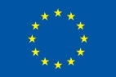

This publication has been produced with the financial support of the European Union Programme for Employment and Social Innovation “EaSI” (2014-2020). The information contained in this publication does not necessarily reflect the official position of the European Commission.
Copyright © EASPD 2017
All rights reserved. No part of this publication may be reproduced, stored in or introduced into a retrieval system without the prior permission of the copyright owners.

Report on the Social Situation of the Population of the Slovak Republic for 2015. https://www.employment.gov.sk/files/slovensky/ministerstvo/analyticke-centrum/sprava-socialnej-situacii-obyvatelstva-za-rok-2015.pdf
Statistic Office of Slovak Republik (2011): Results of Ad hod Module 2011 - Employment of disabled people in Slovakia. staging.ilo.org/public/libdoc/igo/P/49725/49725(2011q4)146.pdf
Report on the Social Situation of the Population of the Slovak Republic for 2015. https://www.employment.gov.sk/files/slovensky/ministerstvo/analyticke-centrum/sprava-socialnej-situacii-obyvatelstva-za-rok-2015.pdf
EC - Country Report Slovakia 2017 Accompanying the document COMMUNICATION FROM THE COMMISSION TO THE EUROPEAN PARLIAMENT, THE COUNCIL, THE EUROPEAN CENTRAL BANK AND THE EUROGROUP 2017 European Semester: Assessment of progress on structural reforms, prevention and correction of macroeconomic imbalances, and results of in-depth reviews under Regulation (EU) No 1176/2011 {COM(2017) 90 final} {SWD(2017) 67 final to SWD(2017) 93 final, https://ec.europa.eu/info/publications/2017-european-semester-country-reports_en
Report on the Social Situation of the Population of the Slovak Republic for 2015. https://www.employment.gov.sk/files/slovensky/ministerstvo/analyticke-centrum/sprava-socialnej-situacii-obyvatelstva-za-rok-2015.pdf
Report on the Social Situation of the Population of the Slovak Republic for 2015. https://www.employment.gov.sk/files/slovensky/ministerstvo/analyticke-centrum/sprava-socialnej-situacii-obyvatelstva-za-rok-2015.pdf
Report on the Social Situation of the Population of the Slovak Republic for 2015. https://www.employment.gov.sk/files/slovensky/ministerstvo/analyticke-centrum/sprava-socialnej-situacii-obyvatelstva-za-rok-2015.pdf
Ministry of Labour, Social Affairs and Family of Slovak Republic (2014): National priorities of social services` development in 2015-2020. https://www.employment.gov.sk/files/slovensky/rodina-socialna-pomoc/socialne-sluzby/nprss-2015-2020.pdf
Ministry of Labour, Social Affairs and Family of Slovak Republic (2014): National priorities of social services` development in 2015-2020. https://www.employment.gov.sk/files/slovensky/rodina-socialna-pomoc/socialne-sluzby/nprss-2015-2020.pdf
European Foundation for the Improvement of Living and Working Conditions (2009): Comparative analysis of working time in the European Union, http://www.eurofound.europa.eu/observatories/eurwork/comparative-information/comparative-analysis-of-working-time-in-the-european-union
Ministry of Labour, Social Affairs and Family of Slovak Republic (2016): The Introduction into the terrain social work in the villages with special focus on work with excluded communities. https://www.ia.gov.sk/data/files/np_tsp/Priloha_c2_Uvod_do_standardov_TSP.pdf.
Perichtová, B. (2011), CEIT: Application of EU WTD in Slovak working conditions. http://www.ceit.sk/IVPR/images/IVPR/vyskum/2011/Perichtova/perichtova_2336.pdf.
EC - Detailed report on the implementation by Member States of Directive 2003/88/EC concerning certain aspects of the organisation of working time (‘The Working Time Directive’). Accompanying document to the REPORT FROM THE COMMISSION TO THE EUROPEAN PARLIAMENT, THE COUNCIL AND THE EUROPEAN ECONOMIC AND SOCIAL COMMITTEE on the implementation by Member States of Directive 2003/88/EC concerning certain aspects of the organisation of working time (‘The Working Time Directive’) {COM(2010) 802 final} ec.europa.eu/social/BlobServlet?docId=6426&langId=en
Perichtová, B. (2011), CEIT: Application of EU WTD in Slovak working conditions. http://www.ceit.sk/IVPR/images/IVPR/vyskum/2011/Perichtova/perichtova_2336.pdf.
Perichtová, B. (2011), CEIT: Application of EU WTD in Slovak working conditions. http://www.ceit.sk/IVPR/images/IVPR/vyskum/2011/Perichtova/perichtova_2336.pdf.
EC - Detailed report on the implementation by Member States of Directive 2003/88/EC concerning certain aspects of the organisation of working time (‘The Working Time Directive’). Accompanying document to the REPORT FROM THE COMMISSION TO THE EUROPEAN PARLIAMENT, THE COUNCIL AND THE EUROPEAN ECONOMIC AND SOCIAL COMMITTEE on the implementation by Member States of Directive 2003/88/EC concerning certain aspects of the organisation of working time (‘The Working Time Directive’) {COM(2010) 802 final} ec.europa.eu/social/BlobServlet?docId=6426&langId=en
European Foundation for the Improvement of Living and Working Conditions (2009): Comparative analysis of working time in the European Union, http://www.eurofound.europa.eu/observatories/eurwork/comparative-information/comparative-analysis-of-working-time-in-the-european-union
European Foundation for the Improvement of Living and Working Conditions (2009): Comparative analysis of working time in the European Union, http://www.eurofound.europa.eu/observatories/eurwork/comparative-information/comparative-analysis-of-working-time-in-the-european-union

